# Media Analysis - ChatGPT

## Short Summary

The article discusses ChatGPT's rapid rise to one million users in five days, highlighting its impact on society and work it notes the effectiveness of AI tools in predicting human behavior but raises concerns about their limitations in true reasoning and ethical implications.

## Summary

1. **Rapid Adoption**: ChatGPT, an AI large language model developed by OpenAI, experienced rapid user growth within five days of its release, with a million unique users.  
2. **Predictability Theory**: The platform's success is based on the theory that human behavior is predictable due to decades of internet and smartphone usage, allowing algorithms to shape our online experiences.  
3. **Data-Driven AI Limitations**: Despite its massive user base, ChatGPT's performance is limited as it relies on analyzing vast datasets to generate content based on data trends, lacking human reasoning capabilities.  
4. **Superficial Predictions**: The author highlights that machine learning systems, including ChatGPT, only provide probabilistic predictions and cannot engage in rational conjecture like humans.  
5. **Ethical Concerns**: OpenAI acknowledges the potential for AI tools to reinforce ideologies and cement truths, raising ethical concerns about their impact on society.  
6. **Lack of Balance**: Noam Chomsky points out that AI tools struggle with balancing creativity and constraint, often producing both truths and falsehoods or exhibiting noncommitment to decisions.  
7. **Collaboration Over Takeover**: The author suggests that the beneficial future with AI lies in collaboration rather than complete takeover of human work, emphasizing that these tools will not change the nature of work but can enhance efficiency.

## Question 1:

How do the media (in our case = the sample we are analyzing) frame the public discussion about ChatGPT? Are there certain **metaphors** that keep cropping up?

The media frame the public discussion about ChatGPT as a groundbreaking technology with staggering adoption rates, leading to debates on its impact. Metaphors include 'turning the world upside down', emphasizing the potential shift in society due to AI, and 'increasing predictability' of human behavior influenced by internet usage.

## Question 2:

Which role does the Arabic World play in the field of Artificial Intelligence in this article according to the author? Answer with 'Not mentioned' if not applicable.

Not mentioned

## Question 3:

How helpful is Artificial Intelligence for the Arabic world based on this article?

The article does not explicitly provide information about the specific benefits or challenges of AI for the Arabic world.

## Question 4:

What is the final message of the article that the author wants to convey? Keep your answer short and precise!

The author stresses the importance of acknowledging AI's limitations, ethical implications, and advocating for human-AI collaboration instead of replacement in shaping work models and society. The rapid adoption of AI tools should not overshadow these considerations.

## Sentiment

The sentiment is 1

## Entities

Microsoft, JOSEPH DANA, Gmail, Twitter ibnezra https, The New York Times Whereas, iPhone, stu, Noam Chomsky, Copyright Syndication Bureau, Google, AI, Exponential View, ibnezra lang, Joseph Dana, ChatGPT-4 https cdn.openai.com, OpenAI, TikTok, Chomsky, Arab News'

## Topic Clusters

### Cluster: AI in society

ChatGPT users, AI-powered world

### Cluster: Technical aspects and concerns

Data processing, AI limitations

## Word Clouds

### Wordcloud of content

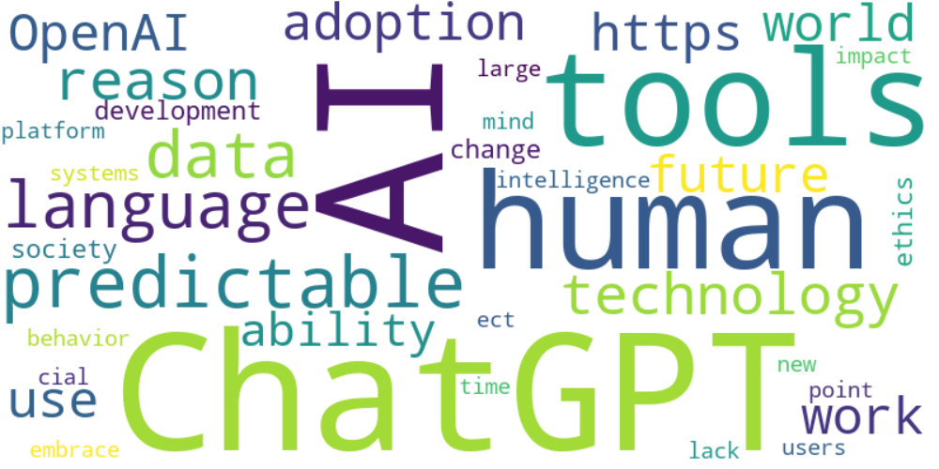

Top 10 words:

- AI: 15

- ChatGPT: 13

- tools: 8

- human: 8

- predictable: 6

- language: 6

- data: 6

- technology: 5

- reason: 5

- adoption: 4

### Wordcloud of summary

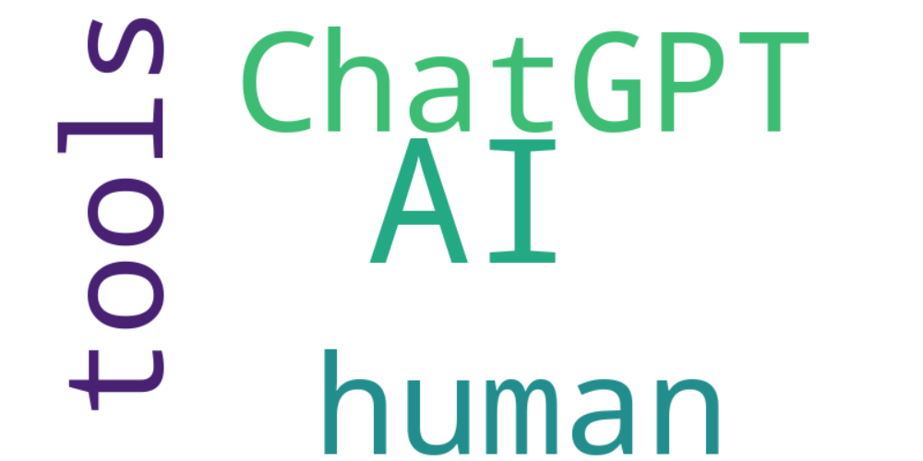

Top 10 words:

- AI: 5

- ChatGPT: 3

- human: 3

- tools: 3